Task 3 was simpler than I thought it was going to be. The overall task was to develop upon task 2 so the program could also reconstruct a paragraph, retrieving information from files that were previously created. Now, previously I mentioned that I don’t think there is any point in creating the index file, and here’s why. The index file is just a file with numbers. That’s it. The numbers have no other value than themselves, so without some sort of dictionary to look up the numbers value, they would be useless in the assembly of the sentence. Each word that was stored in the words file was on its own line for this exact reason. So, that later when they are to be put together, it was obvious what order they needed to be in and minimal effort was required to do so by the program. Anyway, onto how I started task 3.

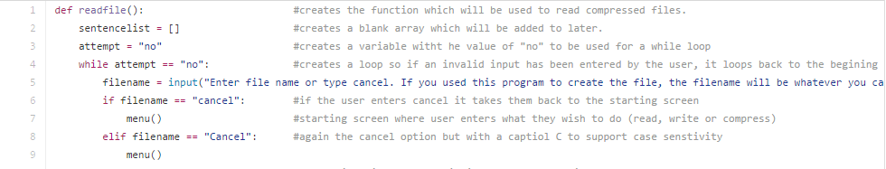

Here you can see the first function which is the main feature of task 3, the ‘decompression’ and reconstruction of a sentence that was previously ‘compressed’ into 2 files. You’re probably thinking, “huh, function?!”. To well structure my task 3, I decided to split it up into 3 functions. A function is almost like a smarter variable. It stores a bunch of code which can later be used just buy stating the functions name. So rather than having to copy and paste code, you can just refer to the function name. Above you can see the first part of the readfile function. It just contains a blank list variable and a while statement which constantly runs the filename input. This is where the user will enter the name of the file they wish to decompress into a sentence. It will only find the file if it is in the same directory as the program is running in. You can see the two if statements basically saying if the user types cancel then return to the menu function. You’ll see what that looks like later. It’s funny because I am literally thinking right now why I didn’t just turn the users input into lowercase so I only needed one if statement. I guess I’ll add that in a sec.

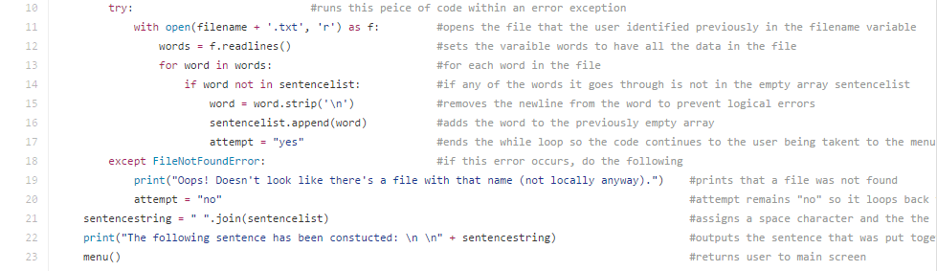

Now here you can see something new. I managed to figure out how to add error exceptions! This really was a breakthrough because one error can stop the entire program from running. To do this you basically write “Try:” and the code block you want it to run underneath it. Then when you’re done, you can write “except” and the error that you could come up followed by the response to the error which in this case is the “Oops, doesn’t look like there’s a file…”. The code block under the try bit is the decompression part. What it does is open the file using the variable that the user previously entered and using a for loop, get each word in the file and add it to the blank sentence list called sentencelist. Oh, and I used the .strip() function to remove the newline that was added to each word. After that I ended the while loop to continue on where I used the .join() function to put together the sentence using all the words in the sentence list. You can also see how if the variable that the user inputted is used for the filename but a file isn’t found, it follows the error exception and outputs “file not found” etc.

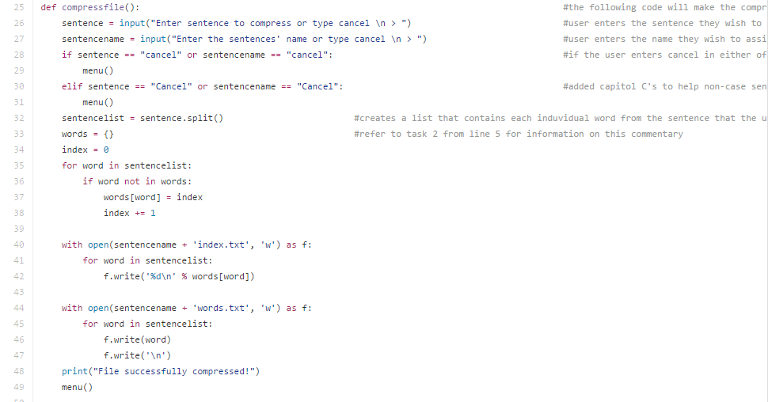

Ok so this next part really doesn’t need that much explaining as it’s literally task 2 put into a function called compressfile. Because that is what task 2 was, compressing a file.

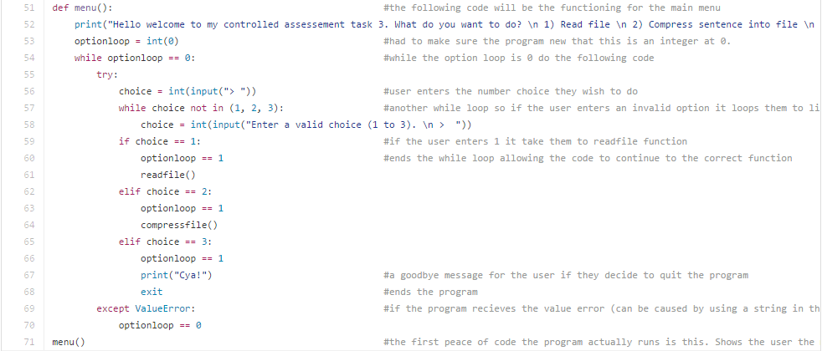

This part is the menu function which is the bridge between all the functions. All it does is print to the user the options that they have, so compress, decompress or quit, and then it takes them to the function. It really is quite simple. It also contains an error exception because if the user entered a string (words) it would go crazy and tell me there was a value error since I declared the input as an integer. You can see at the bottom I have put menu(). This just runs the function when the program start. In matter of fact, it’s actually the first line that is executed by python as functions are ignored unless called upon. So there you have it. Task 3 over and done with. I’ll be sure to add that lower case thing on all the inputs to prevent case sensitivity on the if statements but other than that I’m pretty happy with it.

Update on task 3:

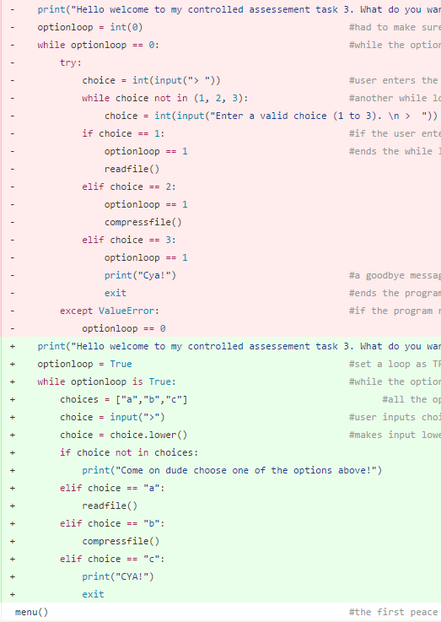Because of many, many changes I made to task 3 I decided to add them here as it is important that you know why those changes were made. Ok, so the first change I made was simply implementing the new code from task 1 and task 2 into task 3 as task 3 contained old version of task 1 and 2 code and needed to be updated. That was fairly simple apart from making sure all the code was properly indented to work within the functions. The second part was cleaning up the menu function. I came about doing this just by simply looking at it. Throughout this coursework I’ve learnt many new skills in python and have been applying them to my work continuously. The menu function is a clean example of that. For some odd reason rather than using a simple Boolean statement for the while loop I decided to make it dependant on an integer variable which made things ridiculously over complicated because It meant I had to go over all the next inputs and make sure they had the right value and not getting strings mixed up with integers. So, I went and changed that so that the options given at the menu are now A, B and C. The input it then made into lowercase to reduce the amount of if statements needed, also all the other variables worked smoothly together because they are now all strings and not a mix of strings and integers. Although that doesn’t sound like much, it really was quite a bit of work and time to go over each line making sure it was up to date. I’ll just show you the updated menu below rather than the whole thing as it wouldn’t fit on the page. If you wish to see the whole thing check out my github page where you can literally see what was replaced with what and why I did it in the commitments section. [Buckballs GitHub](https://www.github.com/buckballs/)